**Monitoring Windows OS with Prometheus**

## Table of Contents

1. [Pre-requisites](https://linuxhint.com/install-monitor-windows-os-prometheus/#A)
2. [Downloading Windows Exporter](https://linuxhint.com/install-monitor-windows-os-prometheus/#B)
3. [Installing Windows Exporter](https://linuxhint.com/install-monitor-windows-os-prometheus/#C)
4. [Adding Windows Exporter to Prometheus](https://linuxhint.com/install-monitor-windows-os-prometheus/#D)
5. [Monitoring Windows with Prometheus](https://linuxhint.com/install-monitor-windows-os-prometheus/#E)
6. [Conclusion](https://linuxhint.com/install-monitor-windows-os-prometheus/#F)
7. [References](https://linuxhint.com/install-monitor-windows-os-prometheus/#G)

## Downloading Windows Exporter

First I downloaded window Exporter from [GitHub page of Prometheus Community’s Windows Exporter](https://github.com/prometheus-community/windows_exporter)

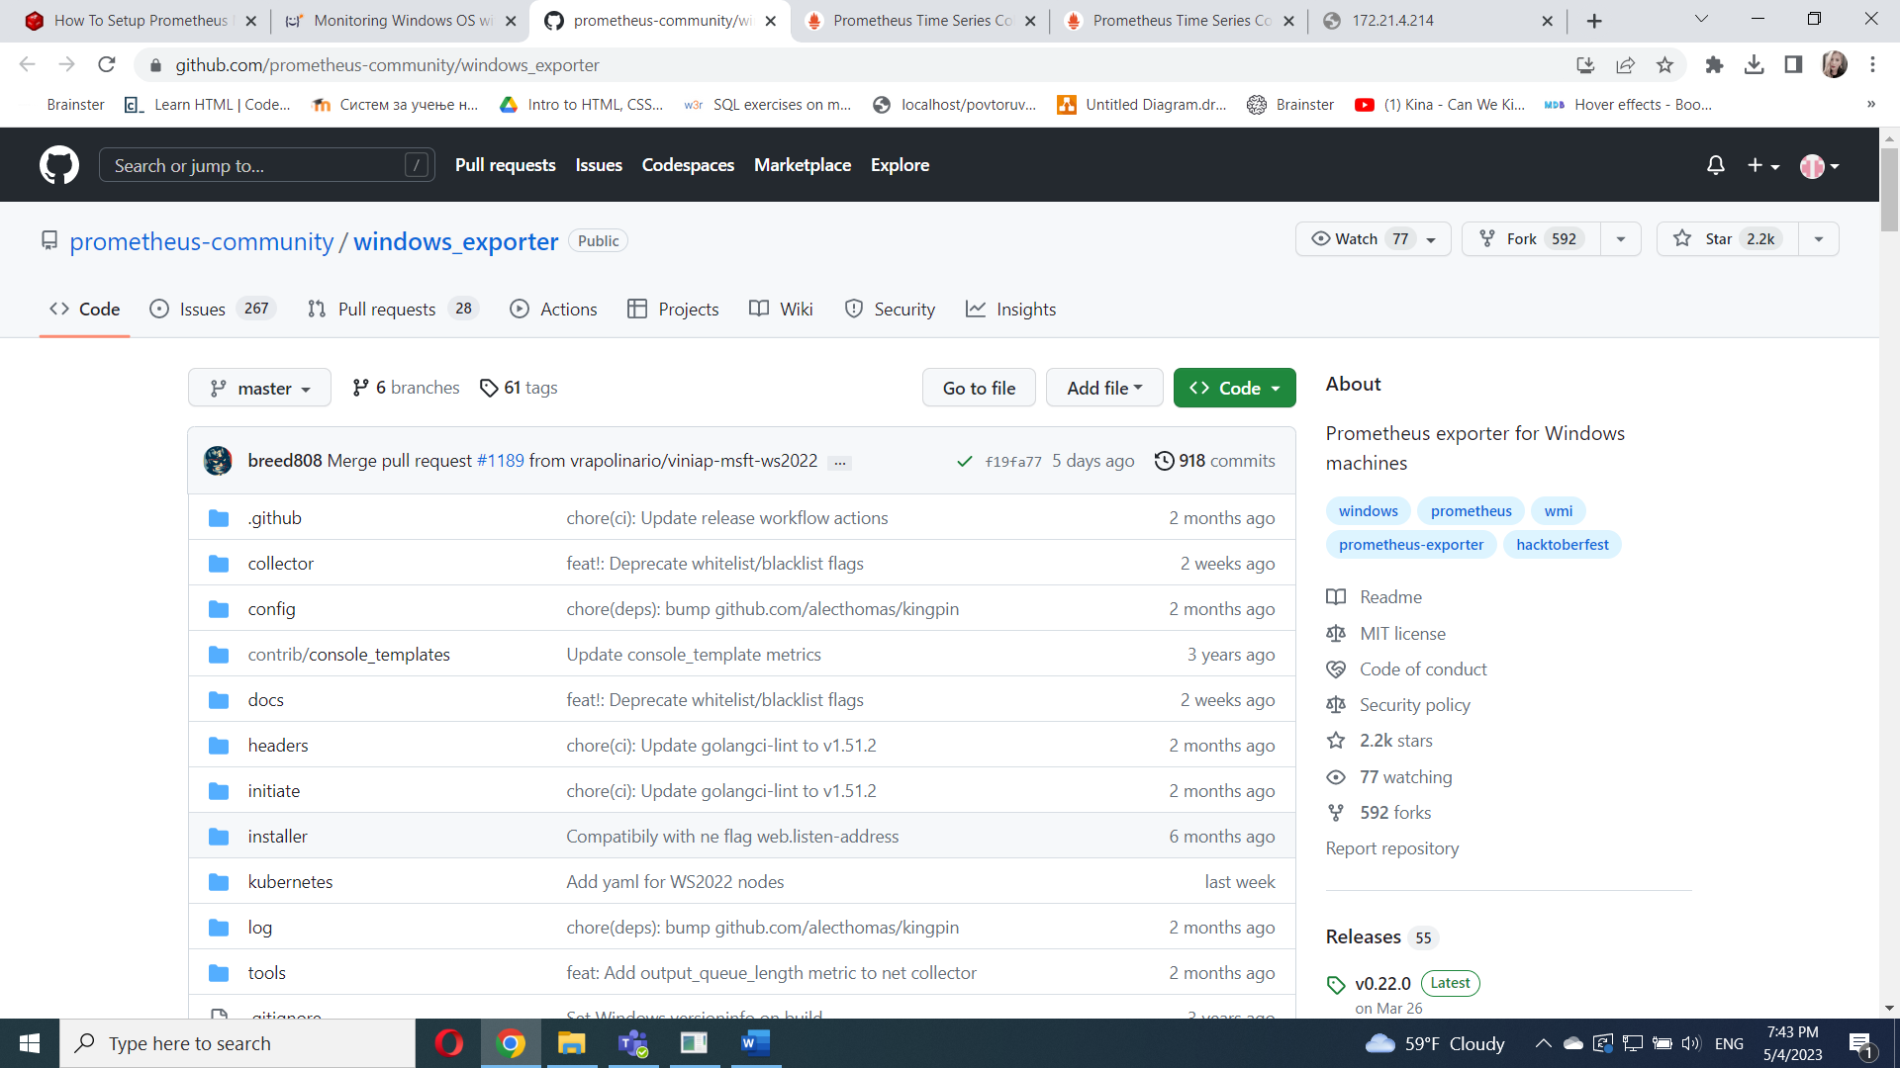

In  **Assets** section I have to download the correct version of the Windows Exporter installer for my computer.( **windows_exporter-*-amd64.msi** link)

## Installing Windows Exporter

There are many collectors in Windows Exporter, and each of them is responsible for exporting specific information. You can get a list of the supported Windows Exporter collectors in the **Collectors** section of the [Windows Exporter GitHub page](https://github.com/prometheus-community/windows_exporter)

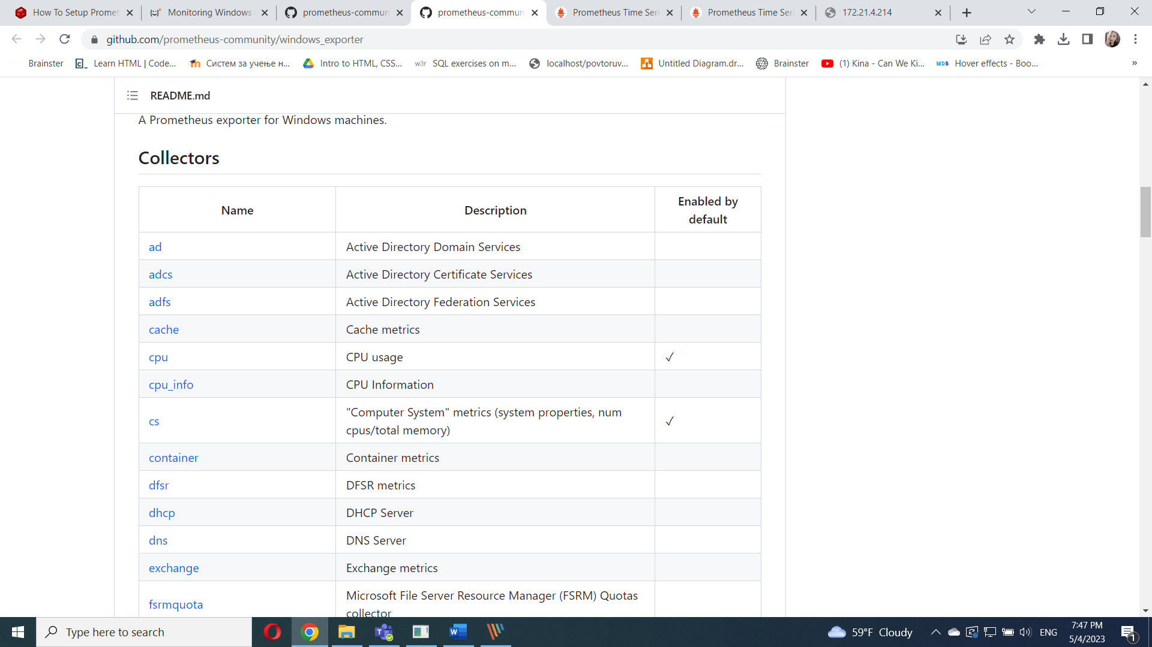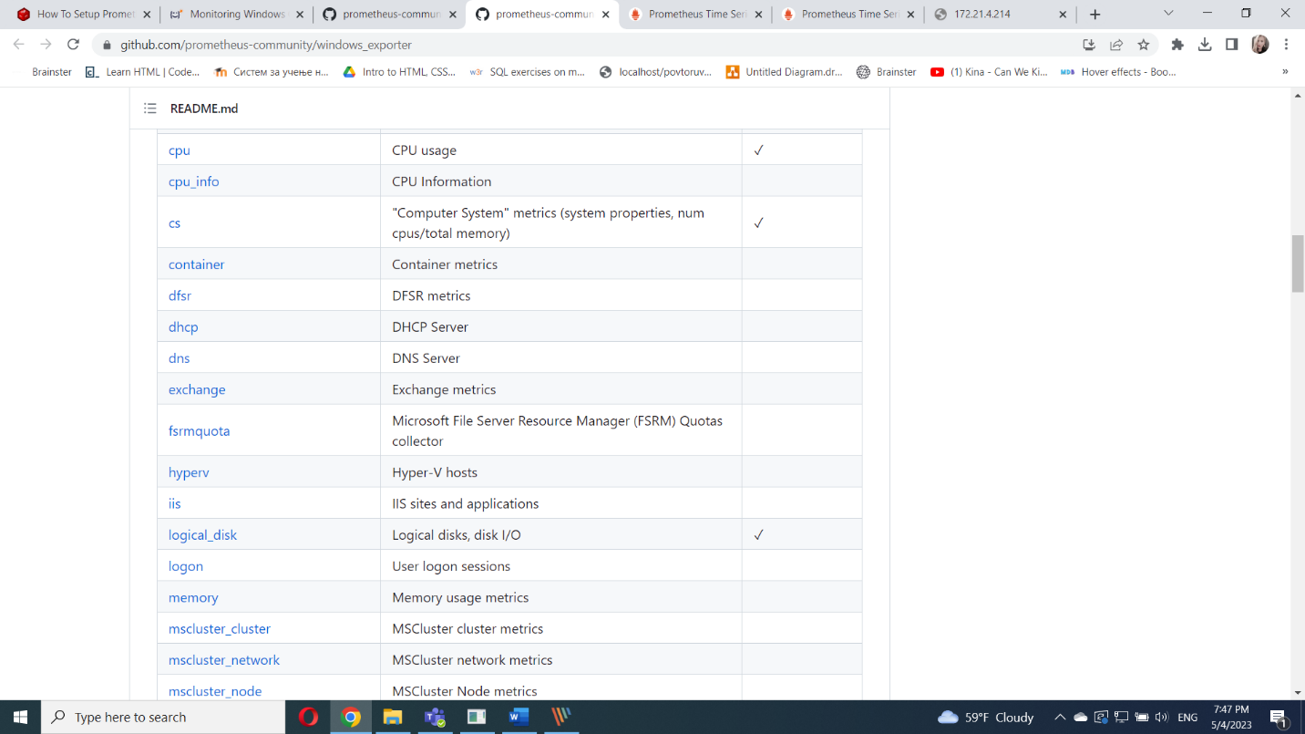

I open cmd like Administrator and navigate to 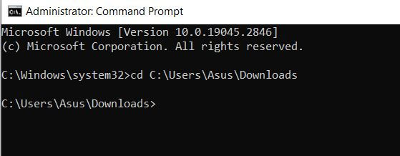

To install **Windows Exporter** and enable only the default collectors, I run the following command: msiexec /i .\windows_exporter-0.16.0-amd64.msi

To install **Windows Exporter** and enable only the default collectors as well as the non-default **memory** collector, I run the following command:

msiexec /i windows_exporter-0.16.0-amd64.msi ENABLED_COLLECTORS="[defaults],memory"

Windows Exporter now is running on port **9182** of my Windows computer.

To verify whether Windows Exporter is working, I open a web browser and visit <http://localhost:9182/metrics>.

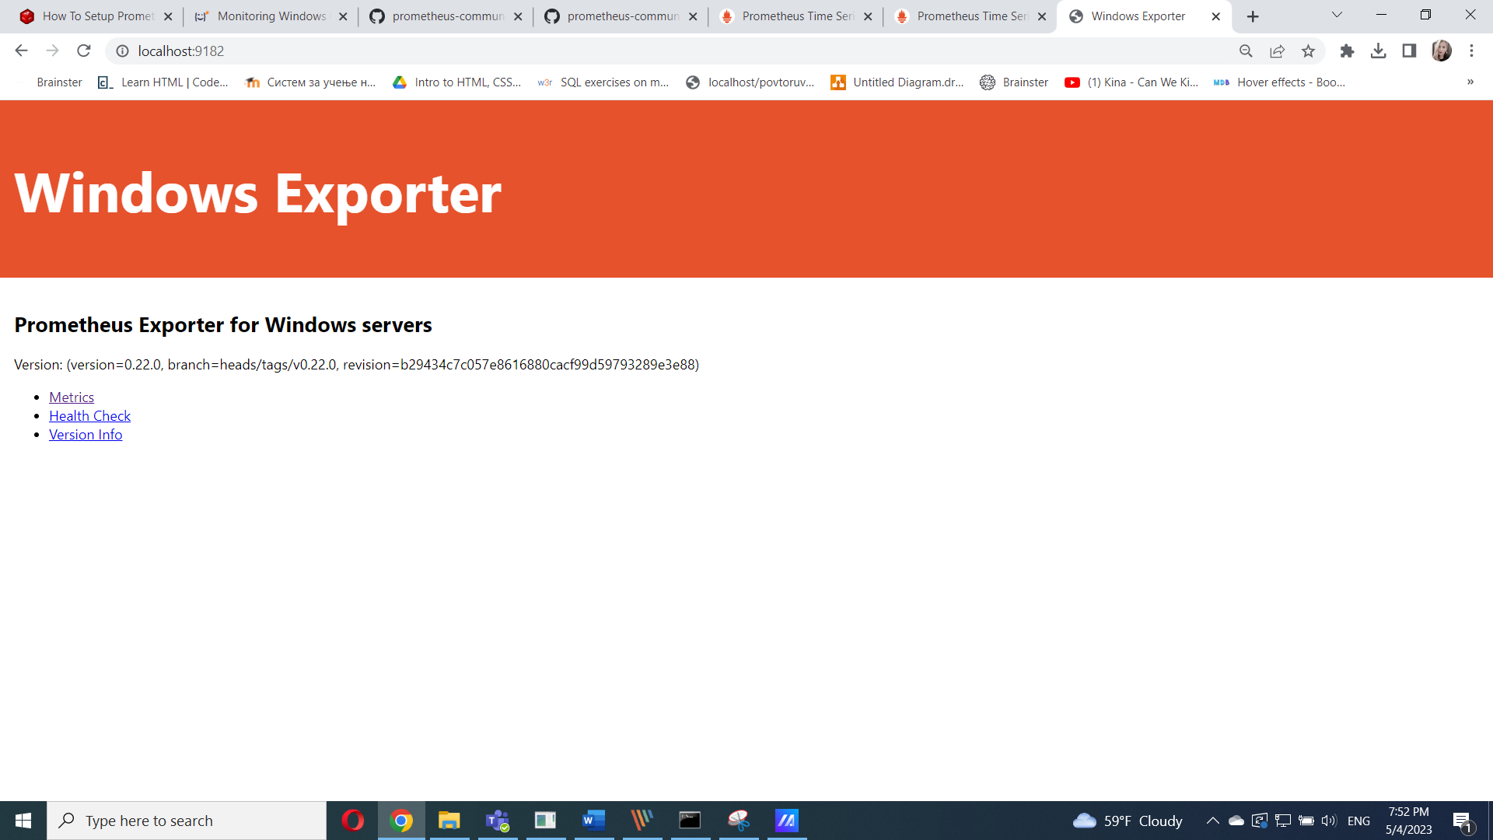

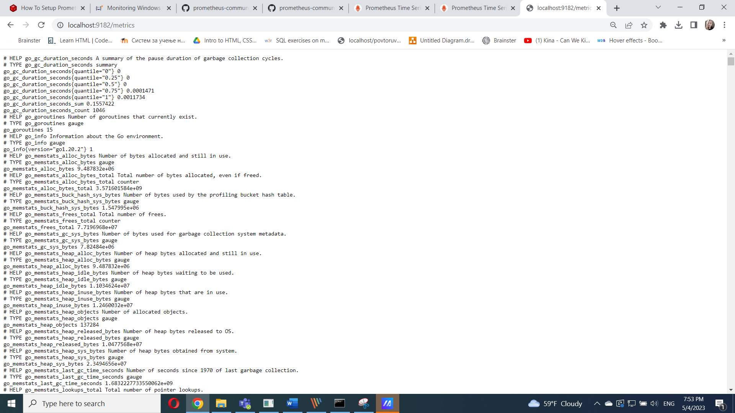

## Adding Windows Exporter to Prometheus

Once the Windows Exporter is installed on my Windows computer, I should be able to add it to Prometheus.

To add my Windows computer to Prometheus, you need to know the IP address of your Windows computer.

To find the IP address of your Windows computer, I can run the following command on the **Command Prompt** app of your Windows computer.

cmd> ipconfig

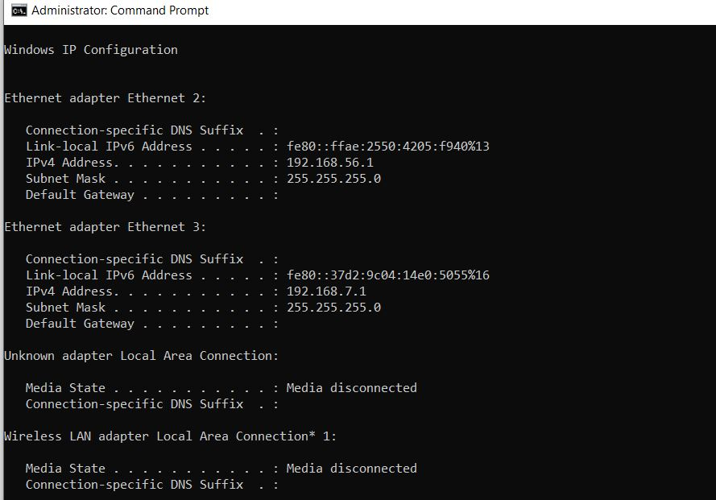

In the Yaml file I added this

  - job_name: 'win10'  
    static_configs:  
    - targets: ['192.168.3.130:9182'] (with my ip adderess)

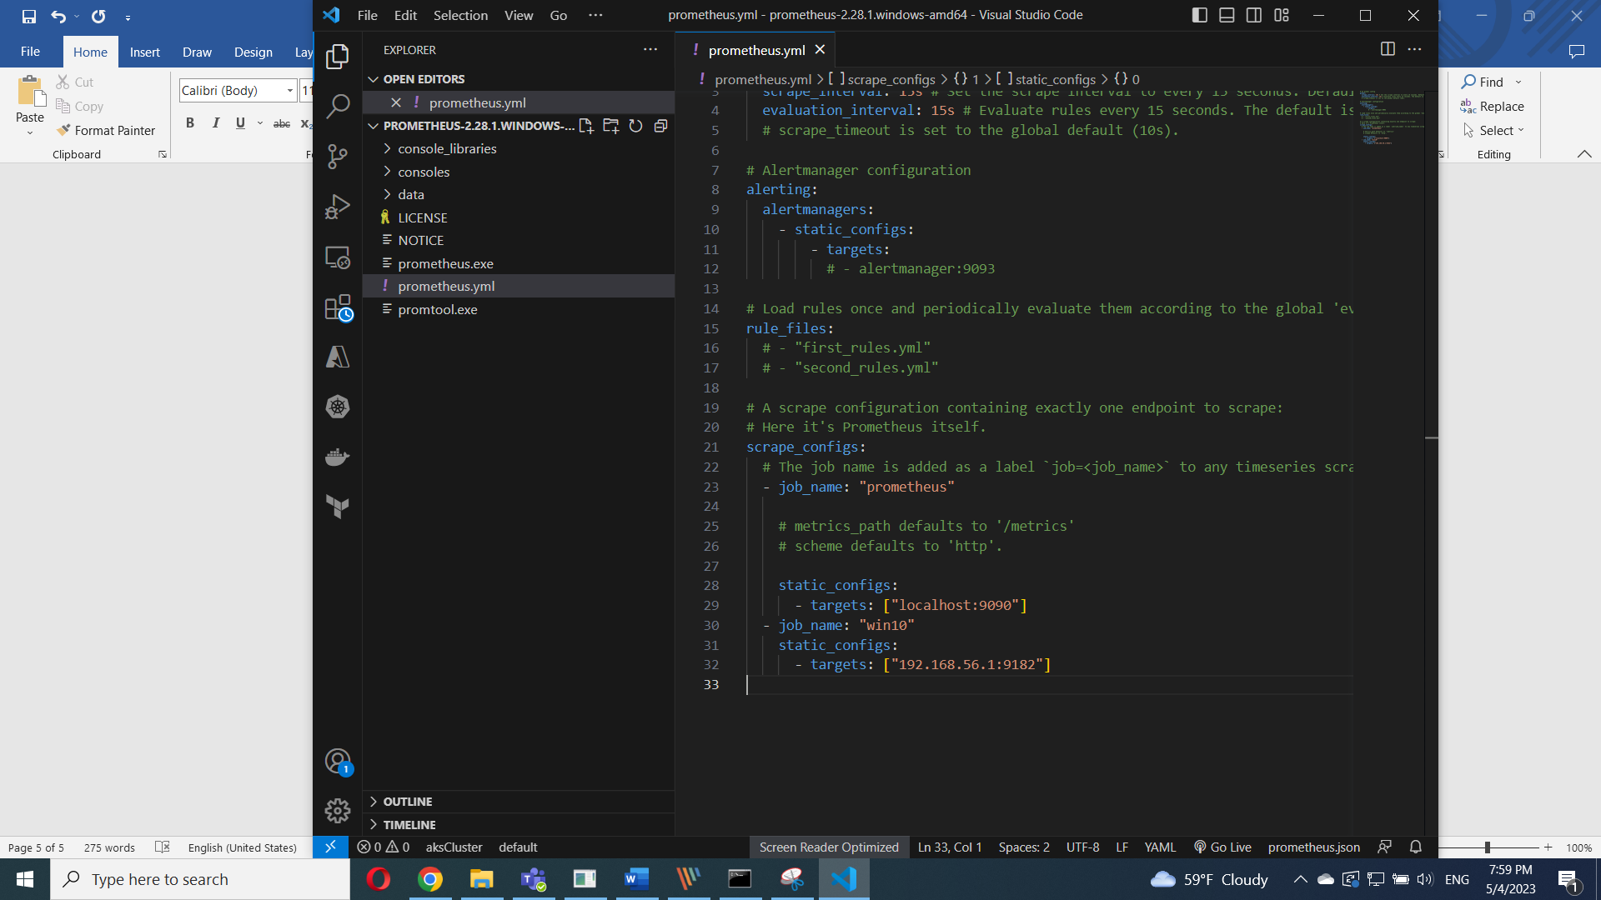

After that I restart it.

To access the Prometheus web interface, I need to know the computer’s IP address where you have installed Prometheus.

$ hostname -I

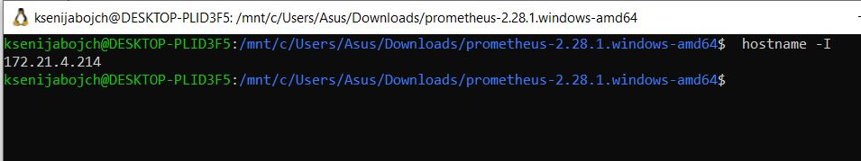

Now, I visit the Prometheus Targets page at **http://192.168.3.149:9090/targets** from favorite web browser, and I should see that the **win10** target is in the **UP** state.

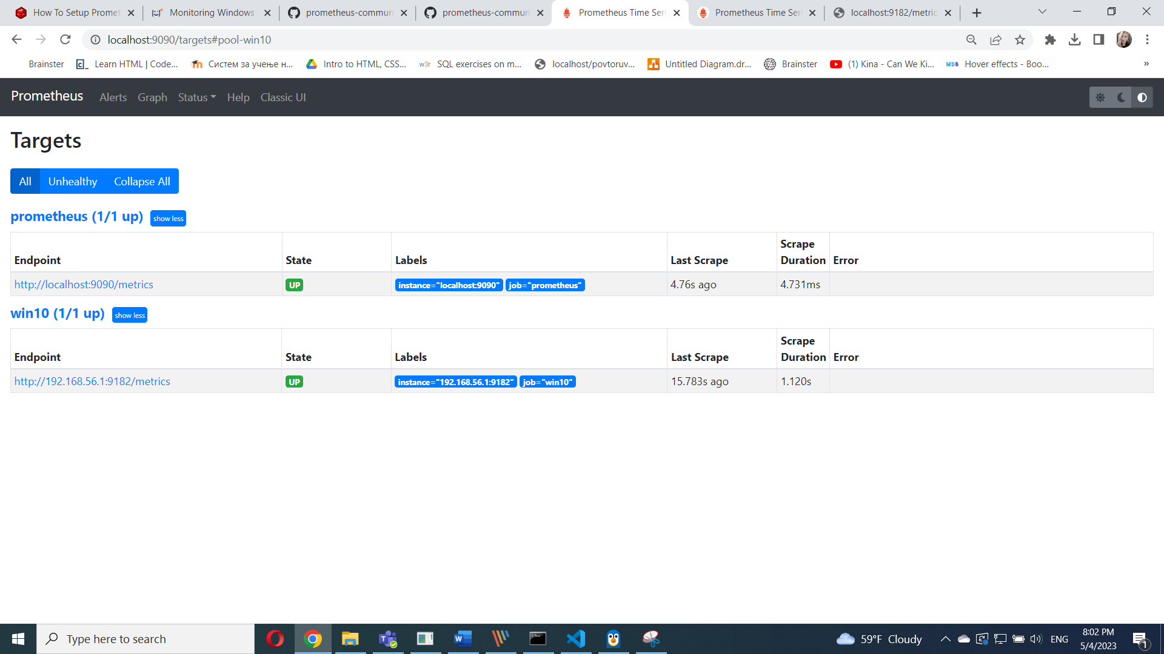

## Monitoring Windows with Prometheus

To monitor Windows computer with Prometheus,I visit the Prometheus Graph page at <http://192.168.3.149:9090/graph> from favorite web browser.

Type in the expression **windows_** and you should see a list of all the Prometheus Windows Exporter metrics as in the screenshot below.

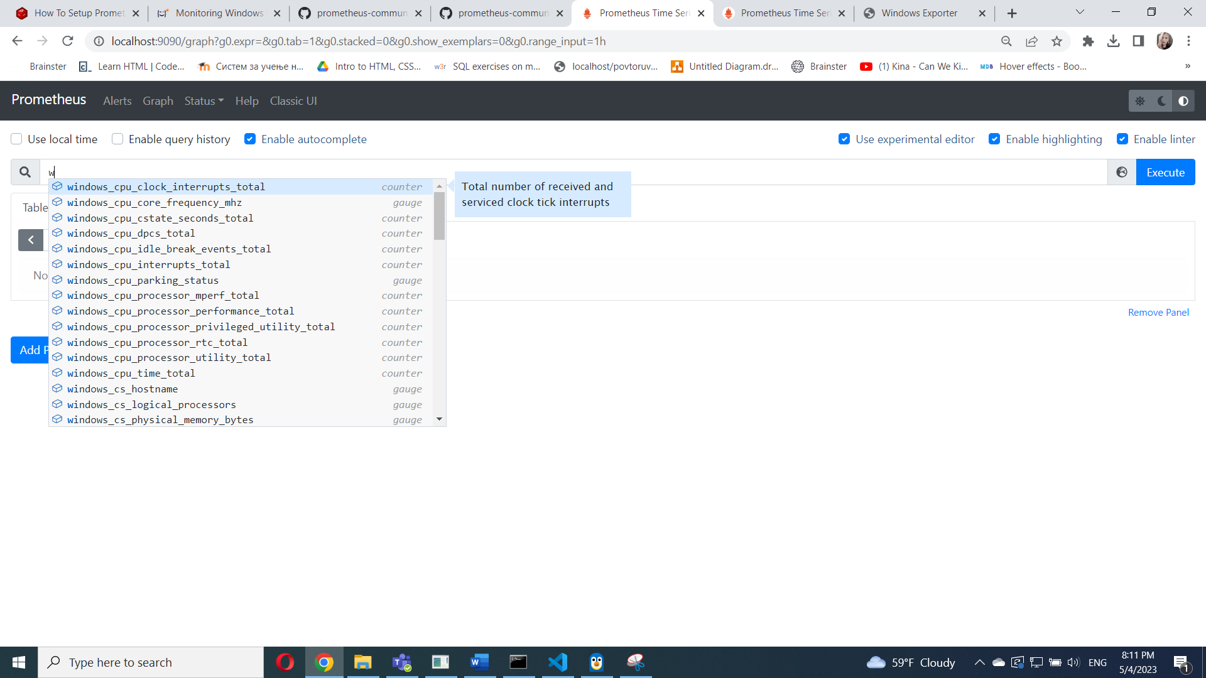

Let’s monitor the download speed of the Windows computer with Prometheus as an example.

To monitor the download speed of your Windows computer, run the expression **rate(windows_net_bytes_received_total[1m])**.

You should see a graph of the download speed of your Windows computer, as shown in the screenshot below.

